PROGRAM 5 : Campus Resource Allocation Under Constraints
1. Problem statement
A college organizes multiple activities that require equipment such as laptops, projectors, and microphones. The available equipment is limited, and each activity has different resource requirements and priority levels.
Develop a Python program that compares the required equipment with the available stock, calculates shortages, and allocates resources according to the specified priority order. Higher-priority activities must receive resources before lower-priority activities. If the remaining equipment is insufficient to meet an activity's full requirements, allocate as much as possible and report the shortage.
2. Objectives
- Store resource requirements for multiple campus activities.
- Compare equipment requirements with available resources.
- Calculate shortages for each activity.
- Allocate resources according to a priority order.
- Ensure that allocations never exceed available stock.
- Display the final allocation and remaining resources.
3. Assumptions and rules
We will use three activities and three types of equipment.
Activity | Priority | Laptops | Projectors | Microphones
AI Workshop | 1 | 5 | 2 | 1
Coding Competition | 2 | 4 | 1 | 2
Cultural Event | 3 | 3 | 2 | 4
Available campus resources:
- Laptops: 8
- Projectors: 3
- Microphones: 4
Priority rule: Priority 1 is the highest. Activities are processed in priority order, and each receives as much of its requested equipment as is available before the next activity is considered.
4. Computational thinking
- Decomposition: Separate the task into storing requirements, sorting activities by priority, allocating resources, and calculating shortages.
- Pattern recognition: Recognize that every activity requires some combination of the same equipment types.
- Abstraction: Focus on equipment quantities, activity priorities, and available stock.
- Algorithmic thinking: Process activities from highest to lowest priority and update the remaining stock after each allocation.
5. Algorithm
- Start the program.
- Store the available equipment in a dictionary.
- Store activity names, priorities, and equipment requirements.
- Sort activities by priority, from highest to lowest.
- For each activity, compare the required quantity of each resource with the remaining quantity.
- Allocate the smaller of the required and available quantities.
- Calculate the shortage by subtracting the allocated quantity from the required quantity.
- Update the remaining stock.
- Display each activity's allocation, shortages, and final remaining resources.
- Stop the program.
6.Flowchart
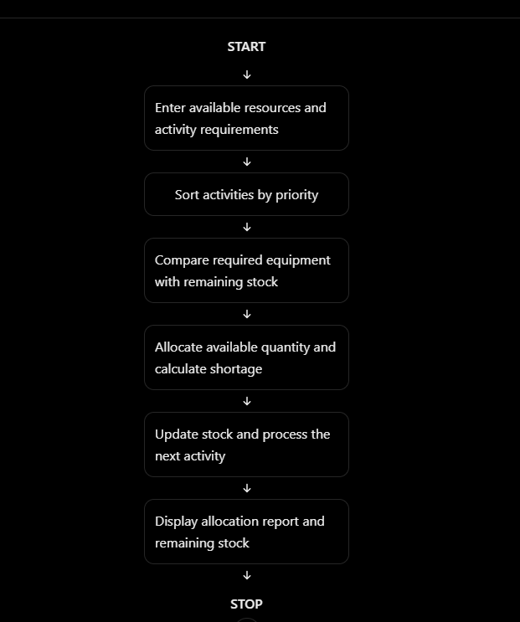

7.PSEUDO CODE
START

Store available resources
Store activity requirements and priorities
Sort activities by priority

FOR each activity
FOR each resource
required = activity requirement
available = remaining stock

allocated = minimum(required, available)
shortage = required - allocated

Update remaining stock
END FOR
END FOR

Display allocations
Display shortages
Display remaining resources

STOP

8.PYTHON SOURCE CODE

# Campus Resource Allocation Under Constraints

# Available campus equipment
resources = {
"Laptops": 8,
"Projectors": 3,
"Microphones": 4
}

# Activity name, priority, and equipment requirements
activities = [
("AI Workshop", 1, {
"Laptops": 5,
"Projectors": 2,
"Microphones": 1
}),
("Coding Competition", 2, {
"Laptops": 4,
"Projectors": 1,
"Microphones": 2
}),
("Cultural Event", 3, {
"Laptops": 3,
"Projectors": 2,
"Microphones": 4
})
]

# Sort activities by priority
activities.sort(key=lambda activity: activity[1])

allocations = {}
shortages = {}

print("===== CAMPUS RESOURCE ALLOCATION =====")
print("Initial resources:", resources)

# Allocate equipment in priority order
for activity_name, priority, requirements in activities:
allocations[activity_name] = {}
shortages[activity_name] = {}

print("\nActivity:", activity_name)
print("Priority:", priority)

for resource, required in requirements.items():

available = resources[resource]

# Allocate only what is available
allocated = min(required, available)

# Calculate shortage
shortage = required - allocated

allocations[activity_name][resource] = allocated
shortages[activity_name][resource] = shortage

# Update remaining stock
resources[resource] -= allocated

print(resource,
"| Required:", required,
"| Allocated:", allocated,
"| Shortage:", shortage)

# Display final allocation report
print("\n===== FINAL ALLOCATION REPORT =====")

for activity_name, priority, requirements in activities:
print("\n", activity_name)
print("Allocated:", allocations[activity_name])
print("Shortages:", shortages[activity_name])

print("\nRemaining resources:", resources)

print("\nAllocation completed.")

9. Test cases
Test case | Condition | Expected result
1 | Enough equipment is available | All requested equipment is allocated
2 | Equipment is insufficient | Available quantity is allocated and shortage is reported
3 | Two activities need the same equipment | Higher-priority activity is served first
4 | No equipment remains | Allocation is zero and the full requirement is a shortage
5 | All activities are processed | Final remaining stock is displayed correctly
10. Expected output
===== CAMPUS RESOURCE ALLOCATION =====
Initial resources: {'Laptops': 8, 'Projectors': 3, 'Microphones': 4}

Activity: AI Workshop
Priority: 1
Laptops | Required: 5 | Allocated: 5 | Shortage: 0
Projectors | Required: 2 | Allocated: 2 | Shortage: 0
Microphones | Required: 1 | Allocated: 1 | Shortage: 0

Activity: Coding Competition
Priority: 2
Laptops | Required: 4 | Allocated: 3 | Shortage: 1
Projectors | Required: 1 | Allocated: 1 | Shortage: 0
Microphones | Required: 2 | Allocated: 2 | Shortage: 0

Activity: Cultural Event
Priority: 3
Laptops | Required: 3 | Allocated: 0 | Shortage: 3
Projectors | Required: 2 | Allocated: 0 | Shortage: 2
Microphones | Required: 4 | Allocated: 1 | Shortage: 3

===== FINAL ALLOCATION REPORT =====

AI Workshop
Allocated: {'Laptops': 5, 'Projectors': 2, 'Microphones': 1}
Shortages: {'Laptops': 0, 'Projectors': 0, 'Microphones': 0}

Coding Competition
Allocated: {'Laptops': 3, 'Projectors': 1, 'Microphones': 2}
Shortages: {'Laptops': 1, 'Projectors': 0, 'Microphones': 0}

Cultural Event
Allocated: {'Laptops': 0, 'Projectors': 0, 'Microphones': 1}
Shortages: {'Laptops': 3, 'Projectors': 2, 'Microphones': 3}

Remaining resources: {'Laptops': 0, 'Projectors': 0, 'Microphones': 0}

Allocation completed.

11. Conclusion
The program allocates campus equipment according to activity priority. It compares the required quantities with the available stock, calculates shortages, and updates the remaining resources after every allocation. This helps colleges distribute limited equipment fairly according to their specified priority rules.

